
OASES Safeguarding Adults at Risk Policy
Updated: 19.11.2025
Next Review Date: November 2026
OASES does not often work with adult at risks, but it is still important for OASES staff to be aware of adult at risk safeguarding policies and procedures to ensure that all adult at risks who come into contact with OASES are appropriately catered for and safe. OASES cares about the welfare of adults and encourages all staff to take their safeguarding responsibilities seriously, reporting any concerns they have immediately and appropriately:
Guidance
All OASES staff are to follow the most up to date HM Government guidance: The Mental Capacity Act 2005 Mental Capacity Act 2005 (legislation.gov.uk) and The Care Act 2014 Care Act 2014 (legislation.gov.uk).
Safeguarding is everyone’s responsibility and for services to be effective each professional and organisation should play their full part but adds that for services to be effective they must adopt a caring approach and be based upon a clear understanding of the needs and views of adult at risks.
For safeguarding procedures to be effective they must reflect the following:
- The adult at risk’s needs are paramount, and the needs and wishes of each adult at risk, should be put first, so that every adult at risk receives the support they need before a problem escalates;
- All professionals who come into contact with adults at risk should be alert to their needs and any risk of harm that individual abusers, or potential abusers, may pose;
- All professionals share appropriate information in a timely way and can discuss any concerns about an individual adult at risk with colleagues and local authority adult social care boards;
- High quality professionals are able to use their expert judgement to put the adult at risk’s needs at the heart of the safeguarding system so that the right solution can be found for each individual;
- All professionals contribute to whatever actions are needed to safeguard and promote an adult at risk’s welfare and take part in regularly reviewing the outcomes for the adult at risk against specific plans and outcomes;
- Local Safeguarding Adults Boards coordinate the work to safeguard adults at risk locally and monitor and challenge the effectiveness of local arrangements;
- When things go wrong Serious Case Reviews (SCRs) are published and transparent about any mistakes which were made so that lessons can be learnt; and
- Local areas then implement changes that are informed by evidence and examination of the data.
As such all OASES staff should follow the Safeguarding Adult at Risk policies, guidance and protocols of the Local Authority in which the adult at risk resides. OASES staff should also follow OASES Safeguarding Adult Policies and Procedures and cooperate fully with Local Safeguarding Boards and the Police.
Safeguarding Training
All OASES staff to be provided with a copy of this policy during their induction.
All OASES staff to receive Safeguarding training within 3 months of employment. It is the responsibility of the OASES CEO to ensure that all OASES staff attend a Safeguarding refresher course every 3 years and Safeguarding Leads repeat their training every 2 years.
All OASES Staff to receive Outdoor and Paediatric First Aid training within 1 month of employment. It is the responsibility of the OASES CEO to ensure that all OASES staff renew their Outdoor and Paediatric First Aid qualification every 3 years.

Safer Recruitment - Background Checks
OASES employs safer recruitment practices:
- Candidates must declare any criminal convictions upon application
- Candidates who have any record of adult at risk abuse will not be considered for employment
All OASES staff must have a clean criminal record. This record must be proven through an enhanced Disclosure Barring Service (DBS) check. OASES will pay for this check to be made and ensure that all OASES staff are placed upon the DBS Update Service – enabling criminal convictions to be reported in ‘real time’.
OASES staff are not allowed to work on their own with adults at risk until a clean DBS check has been evidenced.
OASES Office Manager to complete an annual online status check of the DBS Update Service against all employees in September, at the beginning of the Autumn Term.
It is the responsibility of individual staff members to inform the DBS of any changes to their status e.g. address, marital status etc. This should be done within 1 month of the change occurring.
Where a staff member has worked overseas, a background check from the appropriate country needs to be provided wherever possible, unless they have been a UK resident for more than 5 years.
Voluntary staff must go through the same Enhanced DBS check before starting to volunteer for OASES and will be subject to the same training and protocols as employed staff.

Safeguarding Protocol
Contact Details for Designated Safeguarding Lead:
OASES CEO : Joanne Appleby
Office Number : 03000 260535
Mobile Number : 07870727565

Contact Details for Designated Safeguarding Lead:
OASES Manager : Emma Hawthorne
Office Number : 03000 260535
Mobile Number : 07816 160322

Contact Details for Deputy Safeguarding Lead:
Projects and Programmes Manager : Alice Evans
Office Number : 03000 260535
Mobile Number : 07852982445

Contact Details for Trustee Safeguarding Lead:
Trustee : Dominic Brown
Mobile Number : 01325 730869

Reporting Safeguarding Allegations
You may become concerned about an adult at risk/ an adult working to support an adult at risk by:
- What you have seen.
- What an adult at risk at risk has told you.
- What your staff or volunteers report to you.
- Complaints or allegations from parents or carers.
- How a responsible adult at risk in your organisation behaves.
- Allegations of "historical" or "non recent" abuse.
- Anonymous information.
Some of the reasons that would make you refer are as follows:
- Immediate danger to an adult at risk at risk's welfare.
- Behaviour that does not seem normal.
- A critical incident.
- Several low-level concerns that when put together form a bigger concern.
- Feeling uncomfortable or intimidated by the individual concern.
- Your own instinct.
All OASES staff have a duty of care to the adults at risk that we work with and should report any Safeguarding concerns as follows:
- Immediately – to any other staff members in attendance (if possible).
- As soon as possible – to the OASES designated safeguarding lead, or if unavailable, the deputy safeguarding lead.
- The OASES staff member to document their concerns in writing (using the OASES Safeguarding Incident reporting from) as soon as possible. The account should be factual and contain all relevant details (date, location, people concerned, incident/ what they witnessed). The account should be signed and dated by the staff member and the contact details of any other appropriate witnesses noted. The account should be given to the designated Safeguarding Lead/ Deputy Safeguarding Lead to countersign and file.
- The designated Safeguarding Lead/ Deputy Safeguarding Lead will then contact the Local Safeguarding Team within the relevant Local Authority and provide them with the OASES staff member’s written account.

Whistleblowing
The law is clear that allegations must be referred for investigation when anyone who works with adult at risks, who have a "duty of care" and either in their professional or personal life, have:
- Behaved in a way that has harmed, or may have harmed, an adult at risk.
- Possibly committed a criminal offence against, or related to, an adult at risk.
- Behaved in a way that indicates he/she is unsuitable to work with adults at risk.
Allegations need to be referred to adult at risk social care services within one working day of the concern.
If an OASES staff member witnesses behaviour by another OASES staff member that they consider detrimental to an adult at risk’s wellbeing then they should:
- Challenge the member of OASES staff immediately, preventing further harm from occurring immediately.
- Telephone 999 in an emergency if anyone is in immediate danger of harm
- Not allow the OASES staff member to be alone with any adult at risk.
Then report the incident as follows:
- Immediately – to any other staff members in attendance (if possible).
- As soon as possible – to the Designated Safeguarding Lead, or if unavailable, the Deputy Safeguarding Lead.
- The OASES Designated Safeguarding Lead/ Deputy Safeguarding Lead will then meet with the OASES staff member against whom the accusations have been made immediately and suspend the staff member until all evidence has been heard.
- The OASES staff member who witnessed the incident should document their concerns in writing (using the OASES Safeguarding Incident reporting from) as soon as possible. The account should be factual and contain all relevant details (date, location, people concerned, incident/what they witnessed). The account should be signed and dated by the staff member / any appropriate witnesses. The account should be given to the OASES Designated Safeguarding Lead/Deputy Safeguarding Lead to countersign and file.
- The Designated Safeguarding Lead/Deputy Safeguarding Lead should conduct an investigation immediately, involving the Local Safeguarding Team/ the police for that local area if appropriate.
- The staff member against whom the accusations have been made will remain suspended until a full investigation is completed.
- If the accusations are substantiated the OASES staff member will be dismissed immediately and the Designated Safeguarding Lead/Deputy Safeguarding Lead will contact the Local Safeguarding Team within the area that the incident occurred and within the area in which the OASES staff member resides, so that further investigations can be completed.
- OASES staff are not permitted to talk to the press about safeguarding related issues.

Reporting the Designated Safeguarding Lead/ Deputy
If a staff member has concerns about either the Designated Safeguarding Lead or the Deputy they should report their concerns, using the protocol for Whistleblowing, to the other responsible person. This person will then seek assistance from the Trustee Safeguarding Lead.
If both the Designated Safeguarding Lead and the Deputy are considered complicit then OASES staff should go straight to the Trustee Safeguarding Lead, who will then conduct an investigation and involve the necessary authorities as appropriate:
- General concerns and guidance - the Local Safeguarding Team
- An emergency, where a adult at risk might be in immediate harm - the Police.
If contacting the Local Safeguarding Team remember to say:
"I wish to make an adult at risk safeguarding referral. Can I speak to a duty
social worker?"
Make sure you follow up your referral by:
- Making a factual record of what concerned you: timed, signed and dated.
- Confirming your referral to adult at risk social care services in writing within 24 hours.
Disclosure and Barring Service
If a member of OASES staff is found to have harmed/ shown intent to harm an adult at risk, OASES will work with the Local Safeguarding Team/ the Police to ensure that the Disclosure and Barring Service are made aware immediately.
OASES Safeguarding Incident reporting from
If you witness abuse of any kind record it immediately and make sure that you record everything:
- factually
- signed
- timed
- dated
- on the same day
- using the language used by the person making the disclosure, when applicable.
It is vital that records should be made as soon as possible and on the same day. If an OASES Safeguarding Incident Reporting Form is not available please use a complete sheet of paper, ideally headed.
Try not to record it in your personal diary, as it could become evidence in the future. The Safeguarding Lead/ Deputy Safeguarding Lead will store the records in a secure place until passed on to the relevant agency and record their referral, phone calls, discussions, and actions.
Do remember that any decision not to refer should also be recorded, along with the reasons.
Sometimes the smallest information can be the last piece of the jigsaw to help the relevant agencies decide if there are concerns and what to do to safeguard the adult at risk.
People are never criticised for referring when they have a concern; they will be criticised if they do not at least seek adult at risk’s social care services advice.
If someone is in immediate danger of harm call 999 immediately.

LOCAL SAFEGUARDING TEAMS
The link below takes you to the SAFE website that stores information on each local areas adult at risk’s social care services:
Safeguarding Adult at riskren Boards England (safecic.co.uk)
Lone Working with Adults at Risk
To protect adult at risk and to protect OASES staff, care should be taken to ensure that OASES programmes are designed so that OASES staff are not left on their own with adult at risk. Ideally a member of teaching staff/ public should be present and/ or another OASES team member.
If an OASES staff member finds themselves in a position where they are left alone with an adult at risk, they should try and get back into the public eye as soon as possible. Great care should be taken not to make personal contact with the adult at risk during this time.

Conduct
OASES staff are in a position of trust and influence; hence they should always be approachable, friendly and polite but careful in their conduct. Sensible behaviour should be observed at all times and careful consideration should be given to what is appropriate to any given situation, respecting an adult at risk’s boundaries and rights at all times.
For instance, at no time should a member of staff touch an adult at risk inappropriately in a place considered to be private (bust / bottom). Holding an adult at risk’s hand is acceptable but holding their waist is not – unless as a means of support due to injury, or as a means to prevent injury (i.e., to stop an adult at risk running into a road).

Storage of Allegations / Concerns / Incident / Complaints
All allegations, concerns, incidents, and complaints should be passed onto the relevant authorities immediately (as described above) and kept within OASES secure records (within the personnel filing cabinet). Unless the allegation is proven to be malicious, the record should be retained at least until the worker attains "normal" retirement age of 65, or for a period of 10 years from the date of the allegation, if that is longer. A record should also be placed on his/her file.
It is important that OASES keeps a clear and comprehensive summary of:
- Any allegations made.
- Details of how allegations were followed up and resolved.
- Any action taken.
- Decisions reached.
After an initial assessment by social care services, there are 5 possible outcomes:
- No further action required.
- Disciplinary action.
- Police investigation.
- Referral to the DBS or Disclosure Scotland (who need to be contacted as soon as possible with the written referral, full records of all aspects of the member of staff's recruitment details, training and personnel files)
- Referral to any professional regulatory body for individuals and also organisations, e.g. the CQC, Charity Commission.
- A combination of these.
Other useful documents are contained within OASES Management – OASES Policies - Safeguarding Adults

Summary Points:
It is important to always:
- Take the matter seriously
- Follow OASES’s adult at risk safeguarding policy
- Listen carefully
- Do not ask leading questions or investigate
- Follow the step by step flowchart (below) for when you are worried an adult at risk is being abused
- Monitor, Consult and Record
At all times, observe confidentiality with family and friends.
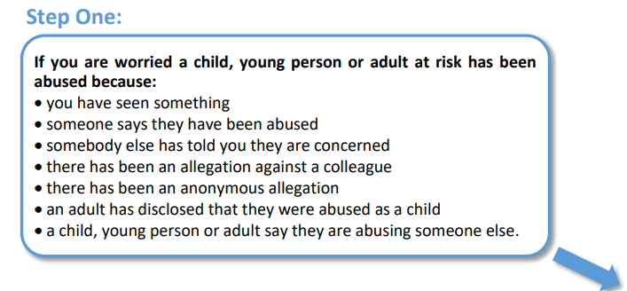

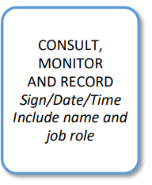
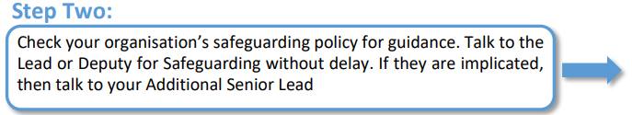


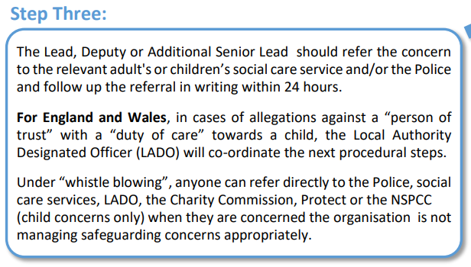

If you do not feel that the matter has been addressed appropriately – remember that a adult at risk’s welfare comes first and you can report it yourself directly to social care services or the police.
If you feel like OASES is mishandling adult at risk safeguarding you can whistle blow to the relevant regulatory organisation as follow:
Care Quality Commission (CQC)  Report a concern if you are a member of staff  enquiries@cqc.org.uk | CQC National Customer Service Centre  Citygate  Gallowgate  Newcastle upon Tyne  NE1 4PA  Tel: 03000 616161

The Charity Commission  Report serious wrongdoing at a charity as a worker or volunteer  whistleblowing@charitycommission.gov.uk | The Charity Commission  102 Petty France  Westminster  London  SW1H 9AJ  Tel: 0300 066 9197

Staff Name | Staff Signature | Date
Staff Name | Staff Signature | Date

