
OASES Safeguarding Children & Young People Policy
Updated: 23.08.24
Next Review Date: January 2025
OASES is a child centred organisation that works primarily with children and young people. OASES cares about the well-being of children and young people and encourages all staff to take their safeguarding responsibilities seriously, reporting any concerns they have immediately and appropriately:
Guidance
All OASES staff are to follow the most up to date HM Government ‘Working Together to Safeguard Children’ guidance. The guidance can be found within OASES Programmes New: Management: OASES Policies or via this link Working together to safeguard children - GOV.UK (www.gov.uk)
Working Together to Safeguard Children reaffirms that safeguarding is everyone’s responsibility and for services to be effective each professional and organisation should play their full part but adds that for services to be effective they must adopt a child centred approach and be based on a clear understanding of the needs and views of children. Every area should use these principles to underpin their safeguarding plans.
In addition, the guidance asserts that for safeguarding procedures to be effective they must reflect the following:
- escalates needs are paramount, and the needs and wishes of each child, should be put first, so that every child receives the support they need before a problem escalates.
- All professionals who come into contact with children and families are alert to their needs and any risks of harm that individual abusers, or potential abusers, may pose to children.
- All professionals share appropriate information in a timely way and can discuss any concerns about an individual child with colleagues and local authority children’s social care.
- High quality professionals can use their expert judgement to put the child’s needs at the heart of the safeguarding system so that the right solution can be found for each individual child.
- All professionals contribute to whatever actions are needed to safeguard and promote a child’s welfare and take part in regularly reviewing the outcomes for the child against specific plans and outcomes.
- Local Safeguarding Children’s Boards coordinate the work to safeguard children locally and monitor and challenge the effectiveness of local arrangements.
- When things go wrong Serious Case Reviews (SCRs) are published and transparent about any mistakes which were made so that lessons can be learnt; and
- Local areas innovate and changes are informed by evidence and examination of the data.
As such, all OASES staff should follow the Safeguarding Children & Young People policies, guidance, and protocols of the Local Authority in which the children attend school.
Safeguarding Training
All OASES staff to be provided with a copy of this policy during their induction and be made aware of the location of the Working Together to Safeguard Children government document and where to find individual Local Authority guidance.
All OASES staff to receive Safeguarding training within 3 months of employment. It is the responsibility of the OASES CEO to ensure that all OASES staff attend a Safeguarding refresher course every 3 years.
All OASES Staff to receive Outdoor and Paediatric First Aid training within 3 months of employment. It is the responsibility of the OASES CEO to ensure that all OASES staff renew their Outdoor and Paediatric First Aid qualification every 3 years.
Safer Recruitment – Background Checks
OASES employs safer recruitment practices:
- Candidates must declare any criminal convictions upon application.
- Candidates who have any record of child abuse will not be considered for employment.
All OASES staff must have a clean criminal record. This record must be proven through an enhanced Disclosure Barring Service (DBS) check. OASES will pay for this check to be made and ensure that all OASES staff are placed upon the DBS Update Service – enabling criminal convictions to be reported in ‘real time’.
OASES staff are not allowed to work on their own with children and young people until a clean DBS check has been evidenced.
All OASES staff members who are teacher qualified to provide their teacher reference number (or equivalent) upon employment. OASES Office Manager to check teacher reference number against the teacher service restrictions list (for all countries worked in) and alert the OAES CEO if the individual has a record that requires investigating. The OASES CEO to complete any investigations as necessary before employment commences.
OASES Office Manager to complete an annual online status check of the DBS Update Service against all employees in September, at the beginning of the Autumn Term.
It is the responsibility of individual staff members to inform the DBS of any changes to their status e.g. address, marital status etc. This should be done within 1 month of the change occurring.
Where a staff member has lived overseas for longer than 3 months in the last 5 years they must supply a Certificate of Good Conduct from those countries, including a translation where necessary.
Voluntary staff must go through the same Enhanced DBS check before starting to volunteer for OASES and will be subject to the same training and protocols as employed staff.

Safeguarding Protocol – Reporting a Safeguarding Concern
Contact Details for Designated Safeguarding Lead:
OASES CEO: Emma Hawthorne
Office Number : 03000 260535
Mobile Number : 00000000000

Contact Details for Deputy Safeguarding Lead:
Projects and Programmes Manager: Alice Evans
Office Number: 03000 260535
Mobile Number: 00000000000

Contact Details for Trustee Safeguarding Lead:
Trustee: Dominic Brown
Mobile Number: 000000000000
If contacting the Local Safeguarding Team remember to say:
"I wish to make a child safeguarding referral. Can I speak to a duty
social worker?"
Make sure you follow up your referral by:
- Making a factual record of what concerned you: timed, signed and dated.
- Confirming your referral to child social care services in writing within 24 hours.
All OASES staff have a duty of care to the children and young people that we work with and should report any Safeguarding immediately – on the day of occurrence/ observation (within a maximum of 2 hours) as follows:
During a school session:
- Immediately - to the staff members in attendance at the time.
- As soon as possible (within a maximum of 2 hours) – to the designated safeguarding lead, or if unavailable, the deputy safeguarding lead.
- The OASES staff member to document their concerns in writing (using the OASES Safeguarding Incident reporting form) within a maximum of 4 hours after the incident. Take a photo of the form and WhatsApp it if necessary.
- The account should be factual and contain all relevant details as indicated by the form (date, location, people concerned, child name, age, address, incident/what they witnessed). Any disclosures should mirror the language used by the person. The account should be signed and dated by the staff member/ other appropriate witnesses. The account should be given to the designated safeguarding lead, or if unavailable, the deputy safeguarding lead to act upon, countersign and file.
- If the OASES staff member/ designated safeguarding lead/ deputy safeguarding lead are not satisfied that the school are taking the matter seriously they should then contact the Local Safeguarding Team within the relevant Local Authority immediately.

During a public session:
- Immediately – to any other staff members in attendance (if possible).
- As soon as possible (within a maximum of 2 hours) – to the designated safeguarding lead, or if unavailable, the deputy safeguarding lead.
- The OASES staff member to document their concerns in writing (using the OASES Safeguarding Incident Reporting form) within a maximum of 4 hours after the incident. Take a photo of the form and WhatsApp it if necessary.
- The account should be factual and contain all relevant details as indicated by the form (date, location, people concerned, child name, age, address, incident/what they witnessed). Any disclosures should mirror the language used by the person. The account should be signed and dated by the staff member/ other appropriate witnesses. The account should be given to the designated safeguarding lead, or if unavailable, the deputy safeguarding lead to act upon, countersign and file.
- The designated safeguarding lead/ deputy safeguarding lead will then contact the Local Safeguarding Team within the relevant Local Authority and provide them with the OASES staff member’s written account immediately.
- The account will be filed within the lockable filing cabinets within the OASES office.

If the OASES staff member witness’s behaviour by the school staff that they consider detrimental to a child’s wellbeing, then they should report the incident as follows:
- Immediately – to the head teacher (if in a school) and/or the Safeguarding lead.
- As soon as possible (within a maximum of 2 hours) – to the OASES Designated Safeguarding Lead, or if unavailable, the Deputy Safeguarding Lead.
- The OASES staff member should document their concerns in writing (using the OASES Safeguarding Incident reporting form) within a maximum of 4 hours. The account should be factual and contain all relevant details (date, location, people concerned, incident/what they witnessed). The account should be signed and dated by the staff member. The account should be given to the OASES Designated Safeguarding Lead/Deputy Safeguarding Lead to countersign and act upon.
- The OASES Designated Safeguarding Lead/Deputy Safeguarding Lead will then contact the head teacher / safeguarding lead of the school to ensure that the incident is reported and being dealt with appropriately and to provide them with a copy of the OASES staff member’s written account.
- If the OASES staff member/ OASES Designated Safeguarding Lead/Deputy Safeguarding Lead are not satisfied that the school are taking the matter seriously they should then contact the Local Safeguarding Team within the relevant Local Authority immediately.

Whistleblowing & Confidentiality
The law is clear that allegations must be referred for investigation when anyone who works with children either in their professional or personal life have:
- Behaved in a way that has harmed, or may have harmed, a child.
- Possibly committed a criminal offence against, or related to, a child.
- Behaved in a way that indicates he/she is unsuitable to work with children.
Allegations need to be referred to children social care services within one working day of the concern/ observation.
If an OASES staff member witness’s behaviour by another OASES staff member that they consider detrimental to a child’s wellbeing, then they should:
- Challenge the member of OASES staff immediately, preventing further harm from occurring immediately.
- Telephone 999 in an emergency if anyone is in immediate danger of harm.
- Not allow the OASES staff member to be alone with any children or young people.
Then report the incident as follows:
- Immediately – to any other staff members in attendance (if possible).
- As soon as possible (within a maximum of 1 hours) – to the Designated Safeguarding Lead, or if unavailable, the Deputy Safeguarding Lead.
- The OASES Designated Safeguarding Lead/Deputy Safeguarding Lead will then meet with the OASES staff member against whom the accusations have been made immediately and suspend the staff member until all evidence has been heard.
- The OASES staff member who witnessed the incident should document their concerns in writing (using the OASES Safeguarding Incident Reporting from) as soon as possible. The account should be factual and contain all relevant details (date, location, people concerned, incident/what they witnessed). The account should be signed and dated by the staff member/ any appropriate witnesses. The account should be given to the OASES Designated Safeguarding Lead/ Deputy Safeguarding Lead to countersign and act upon.
- The Designated Safeguarding Lead/ Deputy Safeguarding Lead should conduct an investigation immediately, involving the Local Safeguarding Team/ the police for that local area as appropriate.
- The staff member against whom the accusations have been made will remain suspended until a full investigation is completed.
- If the accusations are substantiated the OASES staff member will be dismissed immediately and (if they have not done so already) the Designated Safeguarding Lead/ Deputy Safeguarding Lead will contact the Local Safeguarding Team within the area that the incident occurred and within the area in which the OASES staff member resides, so that further investigations can be completed.
Remember, if a child discloses something to you, you cannot promise them confidentiality. If a child requests confidentiality, weigh up the risks and if the child or another child could be harmed, this will outweigh the child’s request for confidentiality.

Reporting the Designated Safeguarding Lead/ Deputy
If a staff member has concerns about either the Designated Safeguarding Lead or the Deputy they should report their concerns, using the protocol for Whistleblowing, to the other responsible person. This person will then seek assistance from the Trustee Safeguarding Lead.
If both the Designated Safeguarding Lead and the Deputy are considered complicit then OASES staff should go straight to the Trustee Safeguarding Lead, who will then conduct an investigation and involve the necessary authorities as appropriate:
- General concerns and guidance - the Local Safeguarding Team
- An emergency, where a child might be in immediate harm - the Police.
Disclosure and Barring Service
If a member of OASES staff is found to have harmed/ shown intent to harm a child, OASES will work with the Local Safeguarding Team/ the Police to ensure that the Disclosure and Barring Service are made aware immediately.
Press
OASES staff are not permitted to talk to the press about safeguarding related issues.

OASES Safeguarding Incident Reporting from
If you witness abuse of any kind record it immediately and make sure that you record everything:
- factually
- signed
- timed
- dated
- on the same day
- using the language used by the person making the disclosure, when applicable.
As a minimum, please record the child’s name, address and age.
It is vital that records should be made as soon as possible and on the same day. If an OASES Safeguarding Incident Reporting Form is not available, please use a complete sheet of paper, ideally headed.
Try not to record it in your personal diary, as it could become evidence in the future. The Safeguarding Lead/deputy safeguarding lead will store the records in a secure place until passed on to the relevant agency and record their referral, phone calls, discussions, and actions.
Do remember that any decision not to refer should also be recorded, along with the reasons.
Sometimes the smallest information can be the last piece of the jigsaw to help the relevant agencies decide if there are concerns and what to do to safeguard the child.
AREA | NAME | NUMBER | EMAIL
Durham | Sharon Lewis | 03000 268835 | cypsladosecure@durham.gov.uk
Sunderland | Safeguarding Team | 0191 5617007 | Safeguarding.Children@togetherforchildren.org.uk
Northumberland | Safeguarding Team | 01670 536 400 | childrentriage@northumberland.gov.uk
Newcastle | Mr Stafford Devine | 0191 277 4636 OR 0191 277 2560 | Stafford.devine@newcastle.gov.uk
North Tyneside | Front Door Children’s Services | Urgent calls  0345 2000109 (9am-5pm) OR  03303337475 (Out of Hours)  General Advice  0191 643 5555 | childrenandadultscontactcentre@northtyneside.gov.uk
South Tyneside | Integrated Safeguarding and Interventions Team | 0191 424 5010 | ISIT-referrals@southtyneside.gov.uk
Darlington | Safeguarding Team | 01325 406 222 | childrensfrontdoor@darlington.gov.uk
Durham | First Contact | 030000267979 | EDT <EDT@durham.gov.uk>
Middlesbrough | Safeguarding Team | 01642 726 004 OR 01642 130 700 | middlesbroughmach@middlesbrough.gov.uk
Redcar | Safeguarding Team | 01642 130 700 | redcarmach@redcar-cleveland.gov.uk
Stockton & Hartlepool | Safeguarding Team | 01429 284284 | childrenshub@hartlepool.gov.uk

If reporting to the local police use 101 unless the child is in immediate danger.
If someone is in immediate danger of harm call 999 immediately.
People are never criticised for referring when they have a concern; they will be criticised if they do not at least seek children's social care services advice.

LOCAL SAFEGUARDING TEAMS
The link below takes you to the SAFE website that stores information on each local areas children’s social care services:
Safeguarding Children Boards England (safecic.co.uk)

Lone Working with Children
To protect children and to protect OASES staff, care should be taken to ensure that OASES programmes are designed so that OASES staff are not left on their own with children. Ideally a member of teaching staff/ public should be present and/ or another OASES team member. If the above cannot be facilitated the OASES staff member should always ensure that other children are present.
If an OASES staff member finds themselves in a position where they are left alone with a child, they should try and get back into the public eye as soon as possible. Great care should be taken not to make personal contact with the child during this time.

Conduct
OASES staff are in a position of trust and influence; hence they should always be approachable, friendly, and polite but careful in their conduct. Sensible behaviour should be always observed, and careful consideration should be given to what is appropriate to any given situation, respecting a child’s boundaries and rights at all times.
For instance, at no time should a member of staff touch a child inappropriately in a place considered to be private (bust / bottom). Holding a child’s hand is acceptable but holding their waist is not – unless as a means of support due to injury, or as a means to prevent injury (i.e., to stop a child running into a road). It is all right to hold a child to consol them if this is done appropriately, it helps the child, and you are in the company of another adult – who can act as a witness to attest to the fact that you were consoling the child.

Storage of Allegations / Concerns / Incident / Complaints
All allegations, concerns, incidents, and complaints should be passed onto the relevant authorities immediately (as described above) and kept within OASES secure records (within the personnel filing cabinet). Unless the allegation is proven to be malicious, the record should be retained at least until the worker attains "normal" retirement age of 65, or for a period of 10 years from the date of the allegation, if that is longer. A record should also be placed on his/ her file.

Other useful documents are contained within OASES Management – OASES Policies - Safeguarding Children
Other relevant policies:
- OASES Staff Handbook – Whistleblowing Policy, Confidentiality Policy, Computer, Internet and Email Policy, Photography Policy, Social Media Policy, External Complaints Handling Policy
- OASES Photography and Film Policy
- OASES ICT Acceptable Use Policy
- OASES Use of Software Policy
- OASES Child Adult Ratio Policy
- OASES Data Protection Polic
Summary Points:
It is important to always:
- Take the matter seriously.
- Follow OASES’s child safeguarding policy.
- Listen carefully.
- Do not ask leading questions or investigate.
- Follow the step-by-step flowchart (below) for when you are worried a child is being abused.
- Monitor, Consult and Record
At all times, observe confidentiality with family and friends.

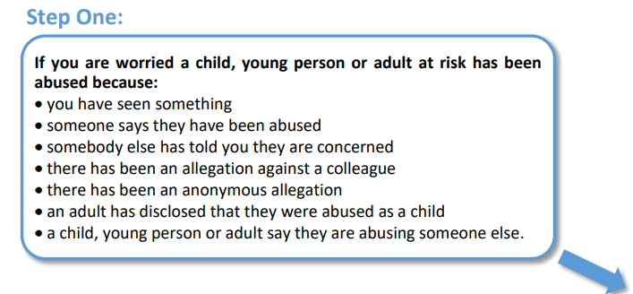

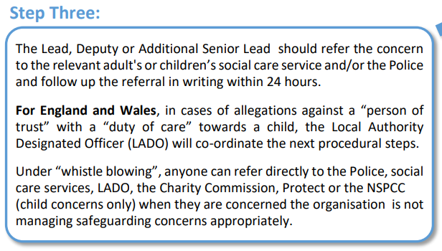
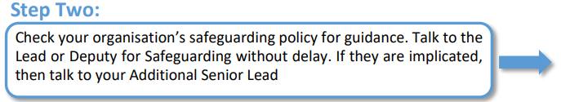
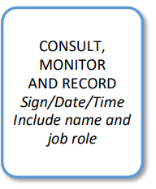



If you do not feel that the matter has been addressed appropriately – remember that a child’s welfare comes first and report it yourself as anyone can refer directly to social care services or the police.
If you feel like OASES is mishandling child safeguarding you can whistle blow to the relevant regulatory organisation as follow
Office for Standards in Education (Ofsted)
How to share concerns about children’s social care services with Ofsted
whistleblowing@ofsted.gov.uk.
CQC National Customer Service Centre
Citygate
Gallowgate
Newcastle upon Tyne
NE1 4PA
Tel: 03000 616161
Children's Services and Skills (Ofsted)
Piccadilly Gate
Store Street
Manchester
M1 2WD
Tel: 0300 123 3155
Care Quality Commission (CQC)
Report a concern if you are a member of staff
enquiries@cqc.org.uk
The Charity Commission
Report serious wrongdoing at a charity as a worker or volunteer
whistleblowing@charitycommission.gov.uk
The Charity Commission
102 Petty France
Westminster
London
SW1H 9AJ
Tel: 0300 066 9197

Staff signature: ……………………………………………………………………………………………………

Date: ………………………………………….

